Protocol
8th Investigators and Management Meeting
16th October, 2019
Institute of Theoretical and Applied Mechanics of the Czech Academy of Sciences
Centre Telč, ITAM CAS, Batelovská 485, 486, Telč, Czech Republic

INTERREG V-A AT-CZ Project
ATCZ133-Kompetenzzentrum MechanoBiologie in Regenerativer Medizin

Table of content
Facts 3
To DO’s 3
Agenda…………………………………………………………………………………………………………………………………..…3
Protocol 4
Scan of the Participant’s list 5
Groupphoto 6

Facts
12 participants present at the Centre Telč, 3 joined via Skype.

To DO’s
- Mid November/December - change of budget to assimilate the extension of the project
- TUV - MR no. 4 and 5
- LP - MR no. 4

Agenda

16-Oct-2019
10:00-10:30 | Arrival, morning coffee
10:30-10:40 | Welcome, Agenda of the meeting
10:40-11:00 | 3D microindentor development & PDMS testing (ITAM)
11:00-11:20 | LBI presentation
11:20-11:40 | FNUSA presentation
11:40-12:00 | USB presentation: New microscopes operating in light transmission and reflection for potential application in development of implants
12:00-13:00 | Lunch break & Group photo
13:00-13:20 | Lead partner presentation (DUK)
13:20-13:40 | Management opening, lead partner summary
13:40-14:40 | Management topics: Project prolongation, cooperation agreement finalization, reporting
14:40-15:15 | Open topics to discuss, agreement on next meeting

Protocol

Investigators Meeting
Petr Zlámal (ITAM)
Actual progress in deformation response measurement of Polydimethylsiloxane (PDMS) substrates
The aim of the test, done in cooperation with FNUSA, was to discover if YAP (Yes-associated protein) is activated by mechanical actuation in cardiomyocytes. P. Zlámal described the requirements of the test, used material (Polydimethylsiloxane (PDMS) based material Sylgard) and the instrumentation. Then he presented the experimental procedure, experiment control (new assembly control unit - real-time kernel based CNC Linux application) and the results.
Time-lapse μCT Analysis of Fatigue Microcrack
Study was focused on in-situ fatigue cyclic loading and its instrumentation for testing of compact bone. Microcrack propagation was investigated base on high-resolution differential tomography. P. Zlámal described the loading procedure, visualization procedure and conclusions. The described method can be used as an important tool for the characterization of the crack propagation phenomena in the bone structure.

Jan Šleichrt (ITAM)
Design of the 3D microindentor device
J. Šleichrt described the progress in designing a 3D microindentor device. The aim is to be able to measure the hardness in volume. Right now, the grinding stage was finished. In the near future it is planned to complete the final design of the safety features, to create drawing documentation for producers of parts, to design a main control unit and to design and electrical schematic/PCB of needed electric systems.

Madhusudan Bobbili - joined via Skype (LBI Trauma)
A Snorkel-tag based method for in vivo isolation of recombinant extracellular vesicles
As a new addition to the LBI Trauma team, M. Bobbili presented his past and present scope of study linked to the Interreg AT-CZ project. He presented the results of in vivo isolation of recombinant extracellular vesicles using a Snorkel-tag based method (Snorkel-tag has no effect on the EV surface protein signature & enables to pull down specific population of EVs, Isolated EVs are functional with intact EV membrane, Recombinant EVs (Snorkel EVs) is a best tool to understand cell-to-cell communication in vivo). He also talked about his future research tasks.

Federico Tidu (FNUSA)
NFAT as a novel pathway in mesenchymal stem cells response to inflammation
Aims of the research are to investigate PRR expression in Ad-MSCs and downstream signaling cascade, to verify presence and responsiveness of Calcineurin-NFAT axis in Ad-MSCs and to understand the impact of Calcineurin-NFAT axis on MSCs gene expression profile. F. Tidu described his progress so far, the ongoing activities and the conslusions (namely: Ad-MSCs express Dectin-1 and TLR4 receptors, TLR4-NF-κB axis enable the cells to sense directly LPS, Ad-MSCs recognize zymosan particulate and activates phagocytic pathway, Zymosan stimulation leads to increased cytosolic calcium concentration and NFAT nuclear translocation, RNAseq data suggest a major role of NFAT in gene associated to extracellular matrix composition (hyaluronate)).

Prof. Dalibor Štys (USB)
New microscopes operating in light transmission and reflection for potential application in development of implants

Prof. Michael Fischer (DUK)
Effects of 2D and 3D amniotic mesenchymal stem cell cultures in influence to platelet lysate

Management Meeting
Extension of the project
- The extension has been negotiated and approved of by the JS.
- The PPs should change their budgets accordingly (personal, material & travelling costs), a new period will be designed.
- All will be addressed before Christmass/mid November and the project manager from the DUK will tell us how to do it.
- It can only be done, if we extend as a team - the JS is not very happy if only a part of the PPs extend.
- PPs confirmed that they have funds left, or will have other sources that can be used to finish the project.

New Handbook for partners
- There is a new Handbook (Version 6) for Interreg AT-CZ partners. https://www.at-cz.eu/cz/ke-stazeni/prijemce or https://www.at-cz.eu/at/downloads/projektpartner.

Reporting
- 3rd Monitoring Report is in the system - TUV was late submitting the report, also LP had to completely change the LP report.
- 4th MR has to be also changed, 3rd and 4th translated.
- After the 4th MR there are no great works planned, so we can report that we are finished.
- After 4th MR we should have spent most of the funds.
- TUV is working on their 4th MR (3rd submitted) - late due to moving of the offices.

Other
- The LP will have another project manager to help with the project.
- Winterschool - 12th-15th January 2020, in Radstadt

Next Meeting
- Around 15th March 2020 in Krems, 1 day
- Joint scientific and management meeting
- Another meeting near the summit of the prolonged project

Scan of the Participant’s list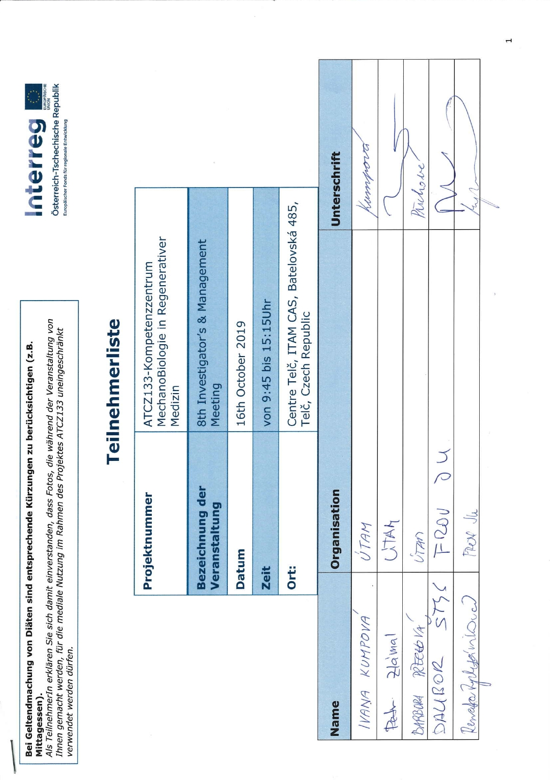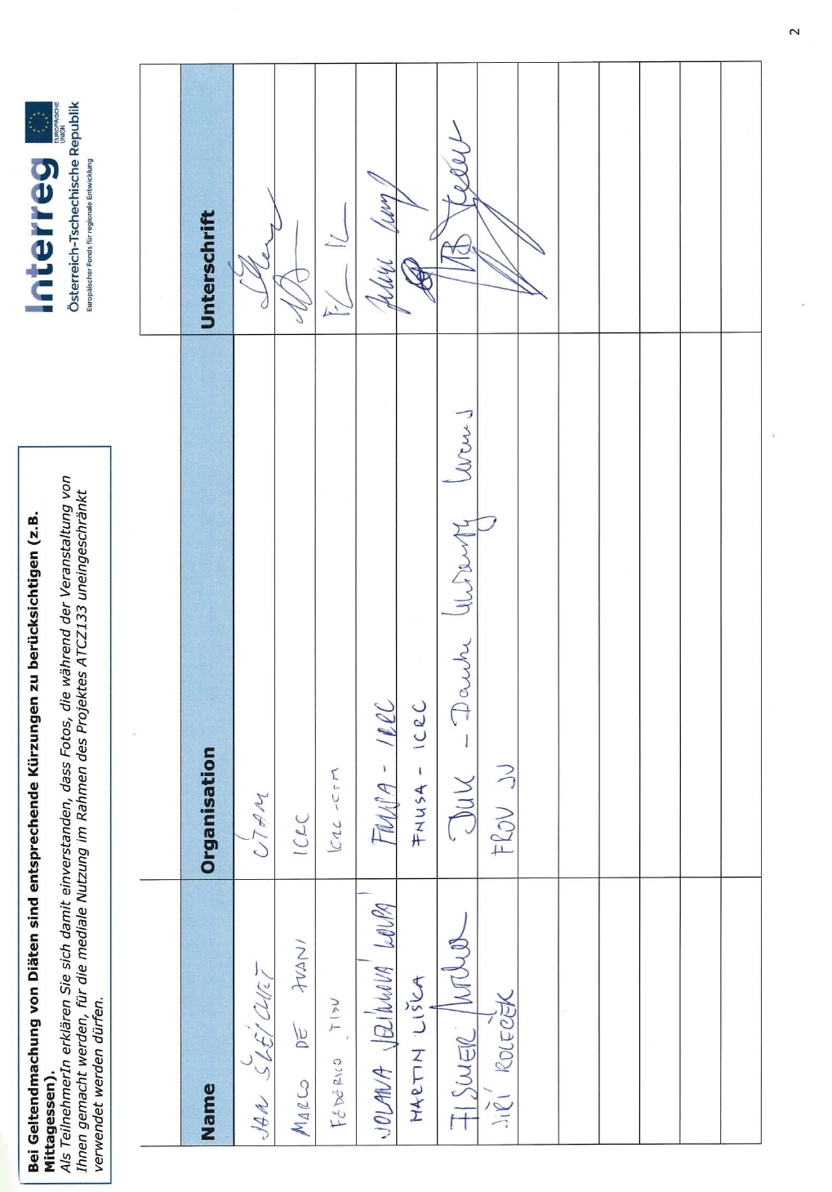

Groupphoto
